EXERCISE 17
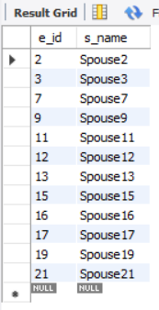
- ﻿﻿﻿Find and list the ids and spouse names of all employees who are married.
SELECT e_id, s_name
FROM employee_per
WHERE m_status = 'Y';

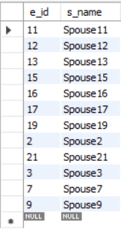
- ﻿﻿﻿Change the above so that the display is sorted on spouse names.
SELECT e_id, s_name
FROM employee_per
WHERE m_status = 'Y'
ORDER BY s_name;

- ﻿﻿﻿How many employees do we have under each sex (male and female)?
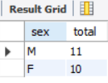
SELECT sex, COUNT(*) AS total
FROM employee_per
GROUP BY sex;

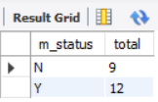
- ﻿﻿﻿How many of our employees are married and unmarried?
SELECT m_status, COUNT(*) AS total
FROM employee_per
GROUP BY m_status;

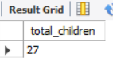
- ﻿﻿﻿Find the total number of children.
SELECT SUM(children) AS total_children
FROM employee_per;

- ﻿﻿﻿Make unique groups of children and find the number in each group. Sort the display with the group having maximum children, at the top.
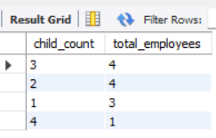
SELECT children AS child_count,
COUNT(*) AS total_employees
FROM employee_per
WHERE children IS NOT NULL
GROUP BY children
ORDER BY total_employees DESC;

